Privacy Impact Assessment (PIA) LITE

NSW Government Digital Channels

Date Issued:
Version:


Scope of PIA Lite
This PIA Lite document identifies potential privacy risks and recommends measures to mitigate these risks related to the collection of personal information by the [Insert Agency] through the following webform/s:

Webform/s Title
Purpose
PI collected
Webform location
Privacy Collection Notice | Based on:  - the type of information collected by the webform/s (personal information only),  - the fact that the provision of information is/is not required by law, and  - the possibility of disclosing personal information to other agencies OR that personal information will not be disclosed to other agencies  Collection Notice – A1 A2 A3 A4 is recommended for this webform/these webforms.  The following wording is recommended to be included in the ‘Purpose of collection’ ‘Information disclosure’, ‘Collection required by law’, ‘Consequences of not providing’ field/s:  ‘Purpose of collection’:  [insert proposed wording]  ‘Information disclosure’:  [insert proposed wording]  ‘Collection required by law’,  [insert proposed wording]  ‘Consequences of not providing’  [insert proposed wording]  Further information about adding a privacy collection notice to a webform can be found in the Using a Privacy Collection Notice for your webform article.
Secure transfer | [Yes/No] | [Secure data location]  Further information about transferring webform submissions and secure data locations can be found in the Creating a webform article.
Data retention | Refer to the applicable retention and disposal authority and the relevant [Insert Agency’s name]’s policies.

Privacy Risks Analysis
NSW Government Digital Channels has assessed the collection of personal information (PI) specified in this PIA against the privacy principles set out in:
- Privacy and Personal Information Protection Act 1998, and
- Information Protection Principles (IPPs) 1-4 (please refer to Appendix B for details).
Based on the Department of Customer Service Risk Matrix (please refer to Appendix A for details), NSW Government Digital Channels has determined that the collection poses LOW privacy risk, given that the webform/s:
- Collect/s limited PI for a purpose directly related to the [Insert Agency]’s function or activities and the collection is necessary and relevant for that purpose
AND/OR
- Use/s free-text fields*
AND
- the PI is collected on a small scale (up to 100 individuals on average complete a webform per month).

[Delete if not applicable] *A free text field element presents a possibility of collecting unnecessary or irrelevant personal information. NSW Digital Channels recommends as best practice including a placeholder text in the text field element, for example: ‘Please only provide personal information that is necessary and relevant to your submission.’

OR

Based on the Department of Customer Service Risk Matrix (please refer to Appendix A for details), NSW Government Digital Channels has determined that the collection poses MEDIUM privacy risk, given that the webform/s:
- Collect/s various types of PI
AND/OR
- allows/requires attaching files that may contain PI (excluding sensitive or health information)
AND/OR
- Involve/s the collection of PI about an individual other than the person completing the webform
AND/OR
- PI is collected on a medium scale (more than 100 but less than 1000 individuals on average complete a webform per month).

If additional privacy risks were identified – delete if not applicable
The table below summarises potential privacy risks related to the collection of personal information specified in this PIA. Recommendations to mitigate the privacy risks are categorised as Compliance (C) actions required to comply with legislative requirements and/or Best Practice (BP) actions.

Risks | Recommended mitigation measures
 | (C)
 | (BP)

If no additional privacy risks were identified – delete if not applicable
No additional privacy risks were identified. The collection of personal information appears to be for a purpose directly related to the [Insert Agency]’s function or activities and the information collected appears to be relevant and reasonably necessary for that purpose.

Approvals and Endorsements
This PIA Lite document was prepared by [name], on [date] with information provided by [name].

Approvals
The following NSW Government Digital Channels employees recommend the project proceeds as proposed in this document.

Name: |  | Signature:
Position:
Agency: | NSW Government Digital Channels | Date:

The following <Insert the Agency> employees recommend the project proceeds as proposed in this document.
Name: |  | Signature:
Position:
Agency: |  | Date:

Add further names as required

Endorsement
The following NSW Government Digital Channels employees have endorsed this document.

Name: |  | Signature:
Position: | Product Delivery Lead
Agency: | NSW Government Digital Channels | Date:

Add further names as required

Appendix A – Risk Rating Matrix

The Department of Customer Service Risk Matrix reported likelihood, consequence, and overall risk rating. For example, Risk rating 4.2.12 represents a Medium rated risk that is likely to happen with minor consequences.
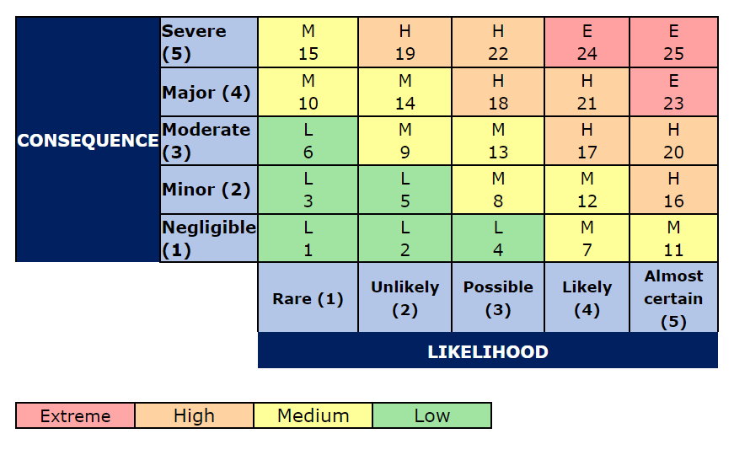

Appendix B – Information Protection Principles 1-4
- Lawful
Only collect personal information for a lawful purpose, which is directly related to the agency’s function or activities and necessary for that purpose.
- Direct
Only collect personal information directly from the person concerned, unless they have authorised collection from someone else, or if the person is under the age of 16 and the information has been provided by a parent or guardian.
- Open
Inform the person you are collecting the information from why you are collecting it, what you will do with it and who else might see it. Tell the person how they can view and correct their personal information, if the information is required by law or voluntary, and any consequences that may apply if they decide not to provide their information.
- Relevant
Ensure that the personal information is relevant, accurate, complete, up-to-date and not excessive and that the collection does not unreasonably intrude into the personal affairs of the individual.

